9/4/2020

Prapti Mane

13491449

Milestone One – Halloween Candy Game

SDV 602 – Milestone One

Contents

Introduction 2

Requirements 2

Game Description 4

Storyboard 7

Storyboard Descriptions 8

Screen 1 : Game Screen 8

Screen 2 Login/Registration Screen 9

Screen 3 Login Screen 10

Screen 4 Login Unsuccessful 11

Screen 5 Registration Screen 12

Screen 6 Game Selection Screen 13

Screen 7 Gameplay Interface Screen 14

Screen 8 Inventory Screen 16

Screen 9 Map Screen 17

Domain Class Diagram 18

Use Case Diagram 19

Initial Functional Test 20

References 23

# Introduction

The game “Halloween Candy” is a mobile based game developed using Unity game development application and C# programming language using Visual Studio 2017 Community version. The architectural software design pattern used to build this game is MVC which stands for Model View Controller.

Architectural software design pattern helps keep our code organized in blocks which is a good approach especially when you have multiple people working on the code.

* **Model** – “It holds the important components of an application”. It basically reflects the real-world things; (codecademy) it is also used to hold the raw data. In the game Halloween Candy, it is in Model where our story text is stored, it also where the different rooms in the game are stored.
* **View** – View is where your scenes are stored, this is where the functions are which helps the user interact with the system. It is this which makes the game/application look nice and helps explain the user the flow of the game/application (codecademy). In Halloween Candy this is exactly what View is doing, it holds all the screens of the game, again it is very helpful when you have your content segregated especially when you have multiple people working on the code, it is considered good practice.
* **Controlle**r – Controller is a liaison between the Model and the View, it receives the user input and then decides what needs to be done with it. The brain of the application sits with the Controller. (codecademy). In the Halloween Candy game the controller holds the files which helps navigate in the game, for example the buttons Maps and Inventory open their own scenes, this code is place in the controller, which helps with the navigation, it lets us know what happens when somebody clicks the Maps button etc.

MVC is a framework which helps organize your files in a better manner. It gives you a starting point for your code and makes it easier for you to go back to your code and not end up spending too much time figuring out which part of the code is located where. It is an organized way of coding. It makes it easy to collaborate with other developers. (codecademy)

# Requirements

Halloween Candy is a 2D text-based adventure game which can be played on a mobile platform. Below listed are the services the player can expect from the game.

* Main screen of the game, which lets the player know what the game is about
* Login using username and password or make a new account if not an existing user
* It is a multi-player game so a player can start their own game or can join a random game
* Inventory which tells the player things they have collected on the way from one room to another, it also lets them know their health.
* Maps which lets the player know their exact location on the house map
* The player can exit the game at any time in the game.

Below listed are the screens which will be in the game, these are the screens the player will be interacting with in the game:

* **The main screen** – This is the screen you first see when you start the game/application for the first time. This screen will let the player know what the game is about, and it will only have one interactive component on it which is an “OK” button which will then take the player to the next screen.
* **Login/Registration Screen** – This is the screen where the player can either tap the Login button to go to the login screen or tap the New user button to register onto the game. The user can tap the Exit Application button to exit the application.
* **Login Screen** – This is the screen where the player types in their username and password and press the Login button to continue to the game screen if the credentials entered are correct if not the player will be taken to another screen with instructions that they’ve entered wrong credentials and the login button on that screen will take them back to the login page.
* **Game Menu –** This is the screen where the player decides if they want to join a random existing game and play with other players or whether they would like to start their own game.
* **Gameplay Interface –** This is the game screen; this is where the player plays the game. On this screen the player can see the text displayed which consist of the story for the game with questions and hints for the player, the screen also has a input text field where the player has to type their answer to play the game, the screen also have the maps and inventory buttons on the screen, if the player taps the map button it will take the player to the map screen which will show the player their current location in the game while pausing the current game, and if the player taps on the inventory button that will take the player to the inventory screen which will show the player all the inventory they have at the moment while pausing the current game. This screen also displays the players health and the candies the player has collected. To exit the game the player can type “exit game” in the text input field.
* **Map screen –** This is the screen which shows the map of the house and the rooms it consists of, this is where the player can see which room he is in and which direction he needs to head to get out of the house, it also has the Game Play button which takes the player back to the Game screen to continue playing the game.

**Inventory Screen –** This is the screen which shows all the objects the player has picked up while playing the game, like candy, potion and magic wand it also shows the player the rooms they’ve visited so far, it also has the Game Play button which takes the player back to the Game screen to continue playing the game. (Todd)

# Game Description

The “Halloween Candy” game is an adventure based text game, here the player cannot see their real character, it is the game of words which is very fun and different from the games we’re used to playing these days.

The way the game works is that the player is a huge mansion with 6 rooms, these rooms have their own special characteristic to themselves, the player will have to go into each of these rooms by choosing their path carefully, and try to get out of the house as quickly as possible. On this adventure the player also needs to collect candies and try to avoid all the ghosts that will try to attack it, cause every time the player gets attacked by a ghost the player loses its health by 20 from 100 which is set at 100 at the start of the game. Another thing that will help the player in this game is the potion and the magic wand, these are some things that the player can use to keep themselves alive. The player gets no added candy when they collect the potions and the magic wand.

The player can keep a track of his potion and magic wand and the rooms they have visited with the help of the inventory screen.

The player can also play this game with multiple players instead of playing it alone. The game can be played with a maximum of 4 players, so they can see who can get out of the house first without being haunted/killed by any ghosts. When the players are playing together, their health and their inventory is their individual one and they cannot share it with each other, even though they’re playing the game together they’re still competing to get out of the house before the other does.

The outcome of the game is that either the player will win the game by getting out of the house successfully or they will end up dying by loosing their health with it reaching to 0.

**Questions asked in the game are:**

**Scenario 1** – This is the question which will appear on everyone’s screen when they start to play the game for the first time:

Welcome to Halloween candy!!! We have a special treat for you.

Collect the most amount of candy as you go but be careful, we do have some scary creatures from the made-up world waiting for you!!

Hope you enjoy your candy...while you can!

If you would like to continue with the Game, please click ok! (the user must click “ok” to continue in the game)

**Question/Scenario 2** – Hospital Hallway

It is a dark room, you hear something coming towards you, You need to get out of this room before that thing comes any closer, Try to 'go North' and maybe you will survive! (user needs to write the command Hint “go north”)

**Question/Scenario 3** – Mirror Room

You're surrounded by mirrors, but there is a way to get out only if you figure out which mirror to look behind… Hint “go east” (user needs to write the command “go east”)

**Future possible questions for the game for the player are:**

You’re in the Mirror Room, would you like to pick up the candy in the corner, beware there is something in that corner, but we do need that candy hint “eat candy” or “go west”

You’re in the Vortex Room, be ready for a whirling experience of your life, hold on to that candy tight, there is plenty of candy for you in this room, but if you hit even a single ghost, you lose your health Hint “eat candy”, “get out of room”

You are in the hallway now what is that behind you? Just do not look back and enter any of the rooms quickly before they see you run!!! Hint “go West”, “go south” “go north” “go east”

Do you feel like you are going in circles? Maybe there really is not a way out…. I see some potion would you like to collect it? Hint “collect potion”

I see you have the potion the ghosts really want now too; do you want to keep it, or would you want to drink it? If you save it, it may help you to save yourself from the ghost, but could also kill you? Hint “don’t drink” or “drink potion”

There is a magic wand in this room, would you like to pick it up and give up your potion? Hint “pick up wand” or “keep potion”

There are 6 rooms the player will visit also go through the hallway to find the candy and the potion and the wand without getting attacked by a ghost, every time the player gets attacked by the ghost they lose 20% of their health. The player must try and get out of the house as quickly as possible with the most amount of candy.

**Every time the player is attacked by the ghost it will show up in a pop as a disaster that the player’s health has been affected, the player must tap the “ok” button to close the window and continue playing the game.**

# Storyboard

Screen 1 Screen 2 Screen 3

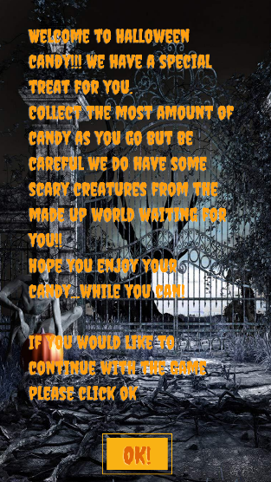 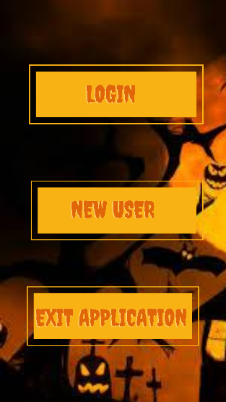 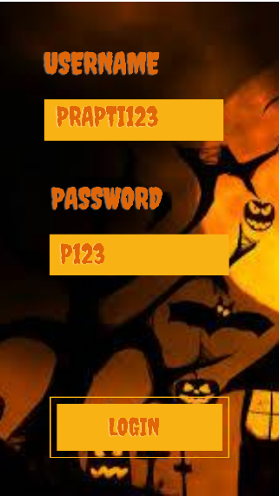

Screen 4 (if Login Successful) Screen 5 (if Login unsuccessful) Screen 6(New User)

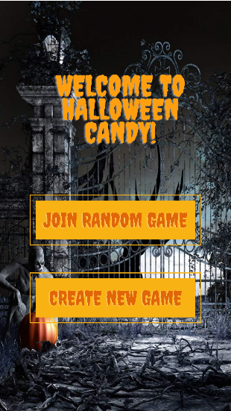 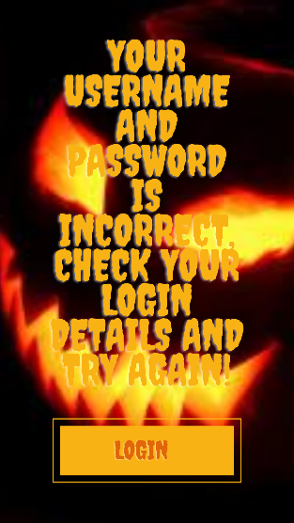 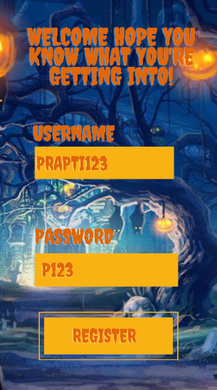

Screen 7 Screen 8 Screen 9

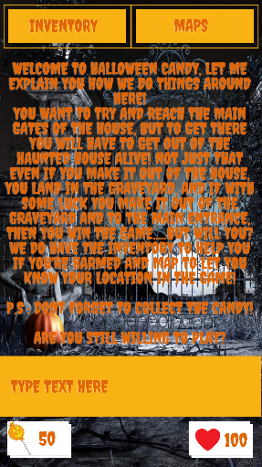 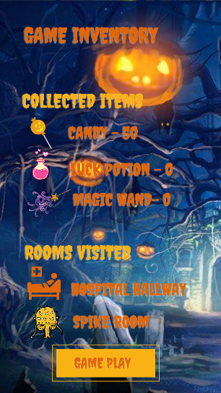 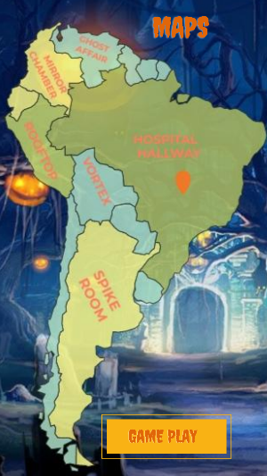

# Storyboard Descriptions

## Screen 1 : Game Screen

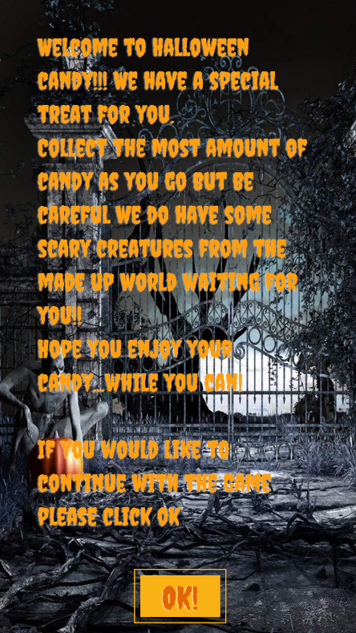

This is the first screen of the Game when you start the application. The user must tap the “OK” button at the bottom of the screen to go to the next screen in the game.

The image come from the <https://wallpapersafari.com/w/rB3MVb> and I have used Canva to manipulate the image to fit to my criteria.

## Screen 2 Login/Registration Screen

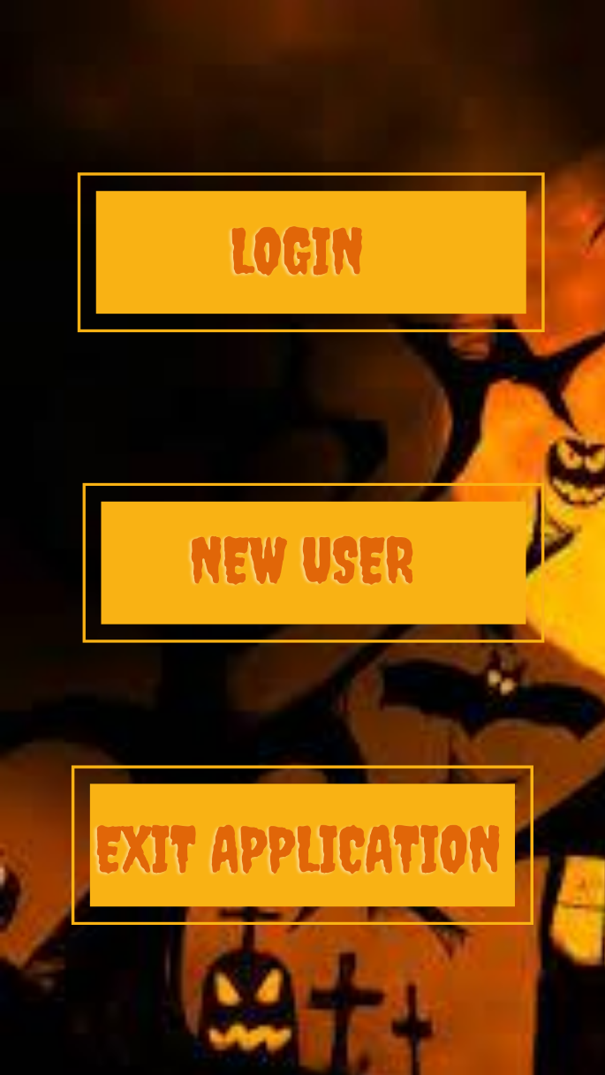

This is the second screen, the user has the option to tap the “Login Button” to go to the Login page, if the user is a new user they can tap on the “New User Button” to go to the Registration page. The player can tap the “Exit Application” button if they want to exit the application and leave the game.

## Screen 3 Login Screen

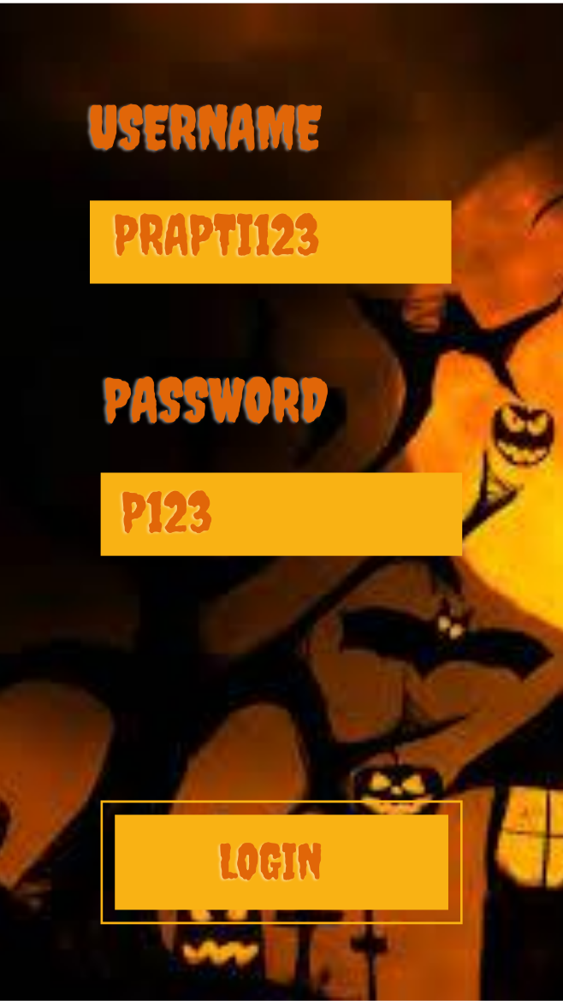

Once the player has landed on the Login Screen, the player must provide their login credentials which is the username and the password and then tap the “Login” button. Depending on the login credentials one of the three things will happen:

* The username does not exist in which case the user will be redirected to the Login/Registration screen to create a new account.
* The username/password is incorrect the user will be directed to the error screen with a message, the player will have to tap “Login” on that screen to try and Login again
* The username and the password is correct and the user is taken to the Game Menu Screen.

## Screen 4 Login Unsuccessful

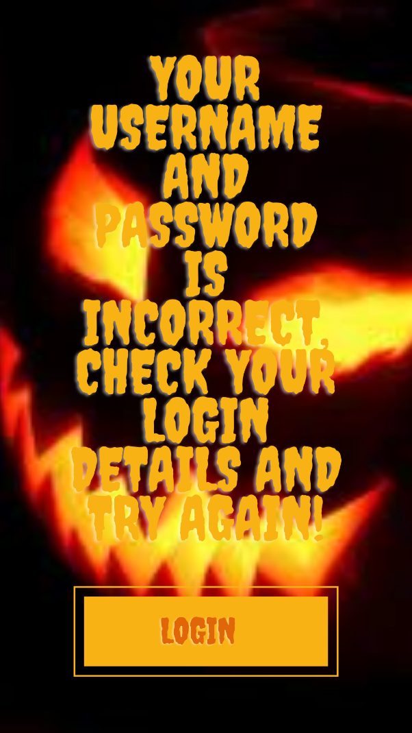

If the user has entered incorrect credentials in the Login Screen they will be directed to this screen, informing them that they have entered wrong login credentials, the user need’s to tap on the “Login button” to try and login again with the right credentials.

## Screen 5 Registration Screen

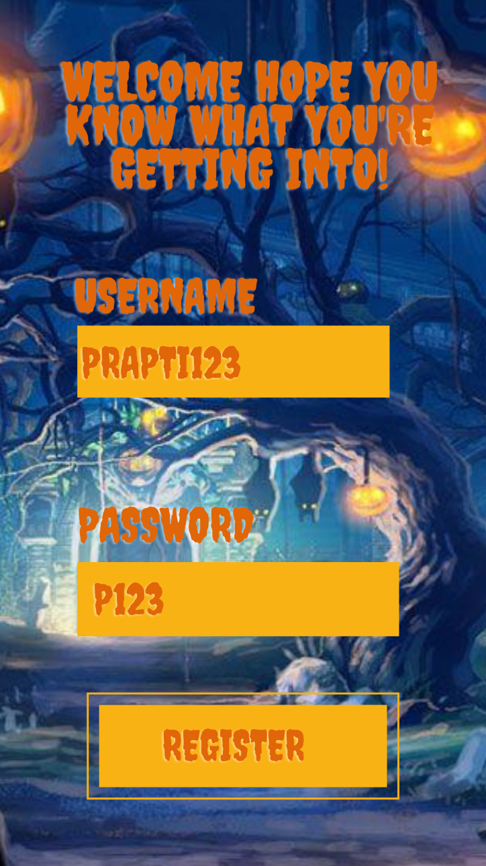

If the user is a new user, after tapping “new user” on the Login/Registration screen the user can create a new account for them by typing in their credentials to make a new account and tap “register”. Once the user has tapped “register button” they will be taken to the Game menu screen directly.

## Screen 6 Game Selection Screen

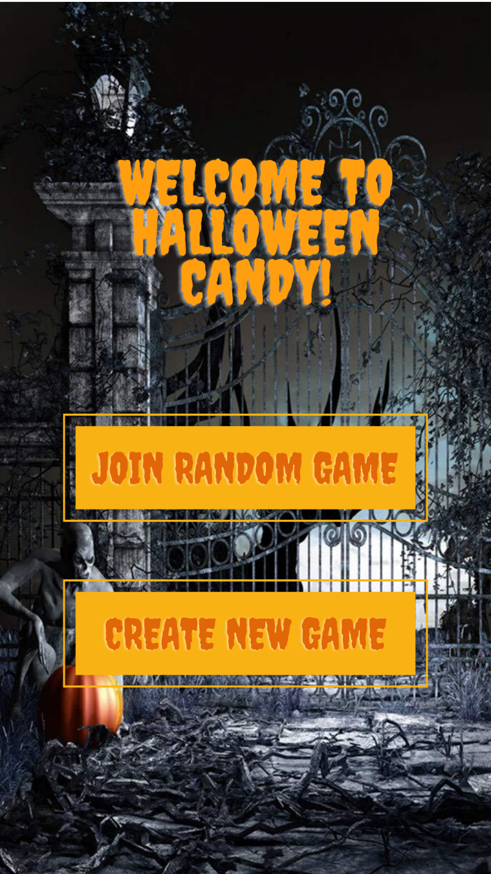

This is the Game menu screen, if the user has logged in successfully, they will be directed to this screen, or by creating a new account they will be directed to this screen. This screen has 2 interactive buttons the user can tap on

* Join a random game button if tapped by the user allows the user to join an existing game, so the user will be place in an existing game with other players, but it will not make much difference to the user’s screen as the user is still competing with other players to get out of the house first, there will be difference with questions letting the user know that there are other user’s in the room, and there will be competition to get to the potion first or the magic wand and the candy.
* Create new game Button if tapped by the user will allow the user to create a new game which will open the gameplay interface with the welcome text in the text display area, the health of the user will be at 100 and the number of candies collected will be at 0.

## Screen 7 Gameplay Interface Screen

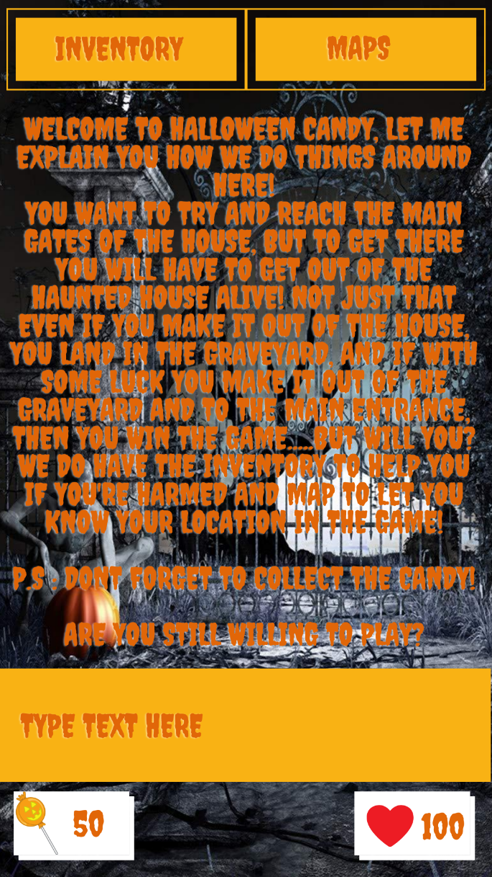

This is the gameplay screen; this is the screen where the user will spend most of their time playing as it is where the game is played.

The screen consists of a text display area which displays the story of the game and the questions which the user will answer to, to move forward in the game to navigate through all the rooms in the haunted house. This screen also has the input text field which allows the user to type in their reply to enter the other room.

If the user has clicked on Create Game

For example, if the text display would say “It is a dark room, you hear something coming towards you. You need to get out of this room before that thing comes any closer Try to 'go North' and maybe you will survive!” this is the hint for the user to type “go north” in the text input field so they do not have to go through the frustration of figuring out the texts as replies, after the user has typed “go north” and hit enter, the text on the Text display screen changes to “Mirror Room - You're surrounded by mirrors, but there is a way to get out only if you figure out which mirror to look behind Hint “go east" once the user types in “go east” the Text on the text display will change to “there is some candy in the corner of this room would you like to collect it before you leave the room? Hint “collect candy”, once the user input is “collect candy”, the candy on the game play screen changes to 50.

The user can tap the “map button” to check their current location in the house as in which room they’re at the moment, and which room they need to get to get closer to their goal of getting out of the house as quickly as possible. The current game is in the pause state when the user taps the “map button”

The user can tap the “inventory button” to check their inventory and see the number of potion, candy and magic wand they’ve collected, the inventory also keeps a track of the rooms the user has visited so far in the game. The current game is in the pause state when the user taps the “inventory button”.

## Screen 8 Inventory Screen

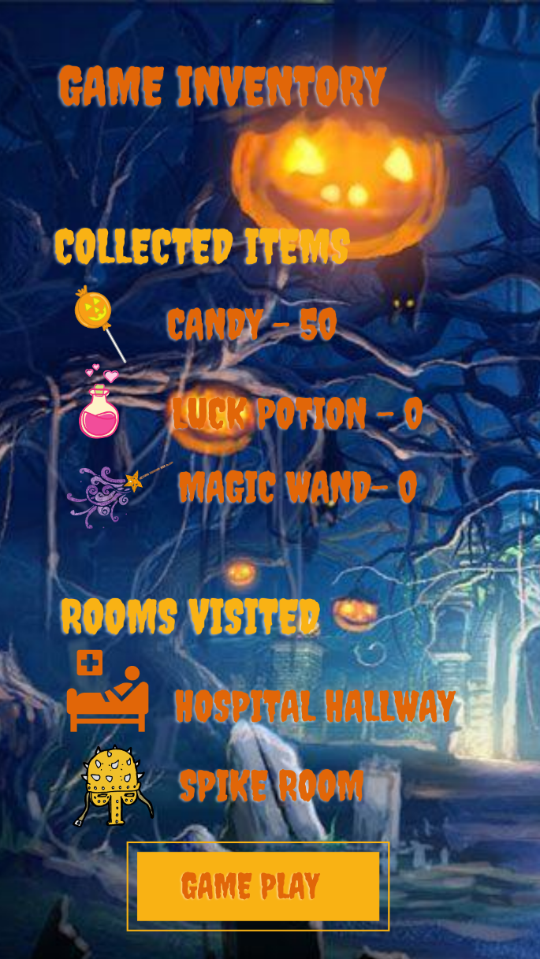

This is the screen where the user can keep a track of the items they’ve collected in the game and the rooms they’ve visited, when the game is started the player visits the inventory every object will be set to 0, and the rooms visited will display nothing under it, once the play starts playing the game and starts visiting the rooms the inventory will start getting updated. The “game play” button will take the user back to the game play screen where the game is on pause since the player has left the game play screen.

## Screen 9 Map Screen

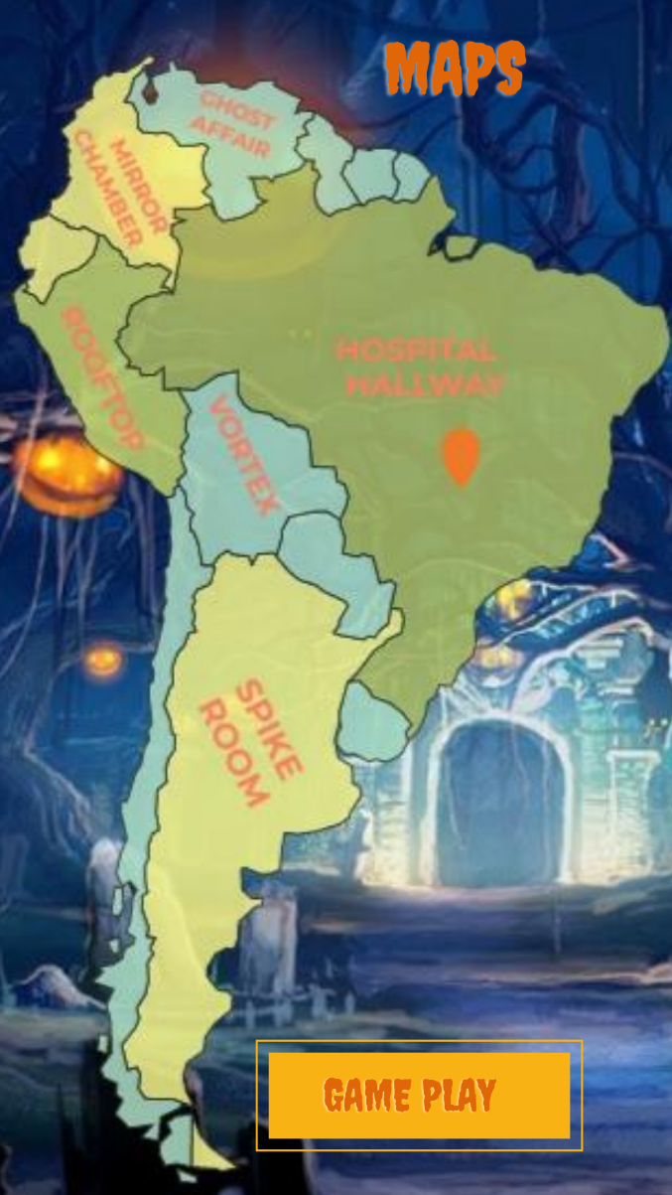

This is the map screen, if the user taps on the “map button” on the game play screen, they will directed to the map screen, this is where the user can find out their exact location on the haunted house map, the current game that the player is playing will be paused when they leave the gameplay screen, if the player taps the “game play button” on the map screen it will take them back to the game play screen to continue playing their game which was in a paused state when the player left the screen to see the map screen.

# Domain Class Diagram

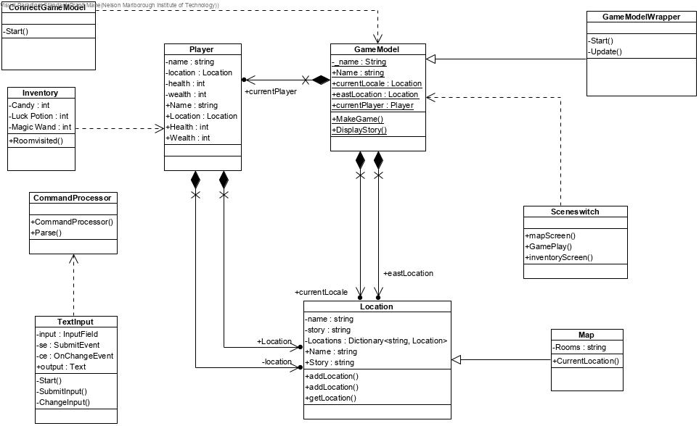

# Use Case Diagram

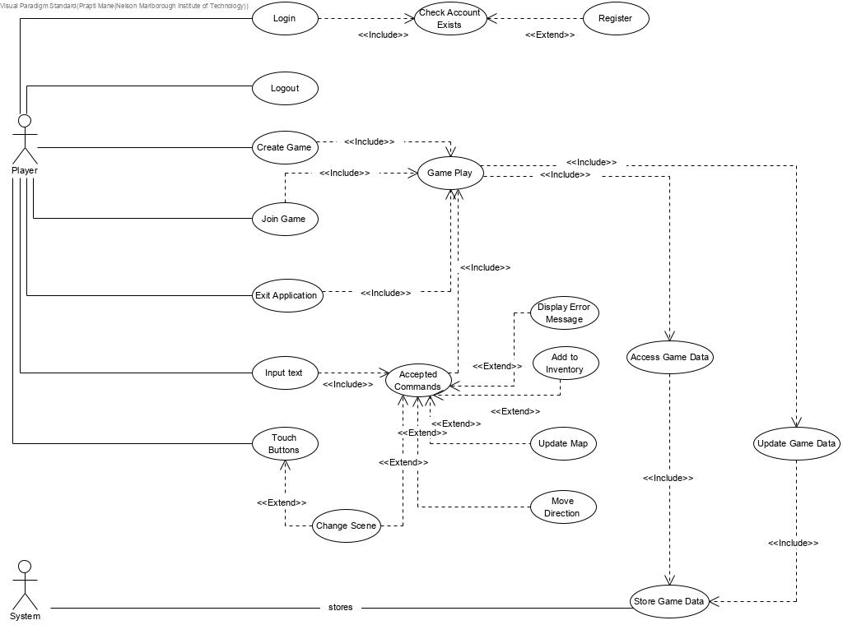

# Initial Functional Test

|  |  |  |  |  |
| --- | --- | --- | --- | --- |
| **Use Case Path** | **Function being Tested** | **Initial System State** | **Input** | **Expected Output** |
| Login/Check Account/Register | User checking their login credentials. If the username and password is incorrect, they’re directed to the error message, where they can try to login again.  If the player if new, they can tap “New User” they will be directed to the Registration page to create an account  If the login credentials are acceptable then the Game Selection Screen is displayed | Login/Registration screen displayed | User taps “Login” and enters username and password on the Login screen  User taps “New User” and enters their new username and password to register on the registration screen | The player has logged in successfully and the Game Selection screen is displayed  New user registered and Game Selection screen is displayed  Login unsuccessful error message is displayed, the player has another chance to login with the right credentials again. |
| Logout | Player gets logged out by the system from the Gameplay interface screen | Player is logged in | Player taps on the “Exit Game” button on the Gameplay Interface screen | Player is logged out and the application is closed |
| Create Game | Create a game and the player’s health is displayed as 100%, starting the game with the welcome story | No game is created | Player taps on the “create Game” button on the Game selection screen | Game is created |
| Join Game | A player gets to join an existing game, with not much change to the gameplay | Game has one player playing | Player taps “Join game” on the game selection screen | Player has joined an existing game |
| Exit Application | The player is exited out of the game | Current running game is still being played | Player taps the “exit game: button on the Gameplay interface screen | Player has been logged out of the game and the application is closed |
| Input Text/Accepted Command | Player enters text in the text input field and then gets checked whether the input is valid or invalid | Text input display has no text in it | Player types in their input in the text input field | Entered command is recognized as accepted or unaccepted |
| Touch Button | System task to check the action when the button is tapped | No interaction with the interface | Player taps the button on the Game screen | Player is taken to the next screen |
| Display error message | Error message displayed to inform the player that the command entered is invalid | Text input is identified as an invalid command | Invalid command | Message is displayed to the player as an error |
| Add to Inventory | Player gets to add potion, magic wand etc to their inventory by typing in “collect potion” | Text input accepted as a valid command | Acceptable command “collect potion” | The item has been added to the player’s inventory |
| Move Direction | By typing in the command in the text input as “go” and the direction the player wants to go, they can change the direction in the game (North, South, East, West) | Text input accepted as a valid command | Acceptable command “go South” | Player’s direction has been changed in the game |
| Update Map | Players current location gets updated on the map | Gameplay interface screen is displayed | Player taps the button “map” | Map screen is displayed with players current location |
| Access Game Data/Store Game data | Data gets stored on the server for long term storage | No data stored on the server | Player Taps “Create Game” on the Game Selection screen | Data gets stored on the server |
| Update Game Data | New data gets sent to the server to store | The server holds the old data | Actions in the game cause the data to change which leads to storing changed data on the server | Updated new data stored on the server |

(Todd)

# References

(n.d.). Retrieved from codecademy: https://www.codecademy.com/articles/mvc

Todd. (n.d.). Retrieved from NMIT: https://ecampus.nmit.ac.nz/moodle/pluginfile.php/1531485/mod_resource/content/2/SDV602%20milestone%201%20report.pdf